Customer Data as the source of SME digital innovation
Szilvia Botos¹, Levente Bálint², Ádám Péntek³, Zsófia Nábrádi⁴
¹associate professor (botos.szilvia@econ.unideb.hu),
²PhD student (balint.peter.levente@econ.unideb.hu),
³assistant professor (pentek.adam@econ.unideb.hu),
⁴assistant lecturer (nabradi.zsofia@econ.unideb.hu),
^{1;3}Institute of Methodology and Business Digitalization, Faculty of Economics and Business, University of Debrecen
²Doctoral School of Management and Business, University of Debrecen; Faculty of Economics and Business, University of Debrecen
⁴Institute of Marketing and Commerce, Faculty of Economics and Business, University of Debrecen
138 Böszörményi út, Debrecen 4032, Hungary
ABSTRACT
Many firms now incorporate digital tools directly into everyday business decisions, since operational efficiency and competitive position increasingly depend on how information is used in practice. This study addresses a research gap, as existing literature rarely examines how handling customer data can support decision making across different SME size groups. Despite broader digital adoption within the EU, smaller firms often struggle to use analytics and social media platforms in routine activities. This often constrains decision making and customer interaction. The empirical analysis relies on a three-dimensional framework built on Eurostat indicators and literature review. Differences between EU SME size categories were tested with One-way ANOVA and Kruskal-Wallis tests, followed by pairwise comparisons. The results, which demonstrate significant variances across the majority of variables, indicate that firm size has a significant impact on digital practices. According to the findings, some medium-sized businesses show trends resembling those of large companies, indicating a transitional stage of digital maturity, even though large companies are more advanced in digital integration. SMEs should concentrate on improving workforce digital skills, implementing reasonably priced open-source solutions, and coordinating digital initiatives with organisational strategy in order to meet the EU's digital goals. A more thorough classification of enterprise size could also support targeted IT development strategies.
KEYWORDS
digitalisation, collaboration, customer relationship, data analytics, SMEs.
JEL CLASSIFICATION CODES
M15 IT Management
O33 Technological Change: Choices and Consequences • Diffusion Processes
INTRODUCTION
The new era of the EU digital strategy brings forward many activities that require not only a robust infrastructure from the business side, but also the application of appropriate methods to collect, store, analyse, and share data and information within the enterprise, with other business processes, and with partners. The strategy is based on the process of digital transformation, which involves additional indicators to express enterprises’ innovation capacity, knowledge, and, of course, their contribution to the new sustainable development goals, through indicators that also relate to digital technologies and applications. How can digital transformation help businesses through digital advancements that connect with customers, e.g., customer data collection, data storage, data analysis, and knowledge transfer? What is the level of these indicators, why are they important, and how can they help to reach not only the digital purposes but the overall business and environmental goals as well? Customers’ data counts as Big Data; thus, we can identify several models and suggest technologies to them, ranging from the rather general description of the processes to specialised application and software solutions that make it real within a framework. And also, from several perspectives, such as the technological aspects of the information flow and its purposes (data preparation for machine learning). The business aspect can involve preparing data to generate insights. In this article, the authors seek to answer these questions by using selected papers closely related to this topic, statistical data aligned with the 3D model, and an analysis by enterprise size categories.
LITERATURE REVIEW
To precisely analyse the preferences, habits, and other characteristics of potential customers and better align with their needs, businesses are collecting more and more personal data about them. Firms can learn about people's preferences and behaviours through social media platforms, which also offer chances for sophisticated data analysis. As a result, customers anticipate that their needs will be acknowledged and given more consideration. Due to this, they are more likely to share their personal information online voluntarily and to believe in and support the commercial use of social media for marketing (Tan et al., 2023). According to Annosi et al. (2023), SMEs can boost sales and grow their clientele by utilising social media and e-commerce. Despite SMEs' comparatively slow adoption of digital tools for day-to-day operations (Jeza & Lekhanya, 2022), research already demonstrates the discernible effects of digitalisation on financial performance (Truant et al., 2021). According to Morabito (2015), Big Data technologies enable more accurate customisation of goods and services. Businesses can track individual customer information, such as locations, demographics, incentive responses, purchasing patterns, and views expressed on blogs, social media, and online discussion boards. By combining structured and unstructured data from multiple systems, including ERP, CRM, and HR systems, using business intelligence tools, SMEs can improve the effectiveness of their decision-making (Limpeeticharoenchot et al., 2022). For many SMEs, competitiveness increasingly depends on whether digital tools are integrated into everyday managerial decisions (Seppänen et al., 2025). Big Data and analytics make it possible to maintain long term customer relationships by supporting more personalised offers (Buttle & Maklan, 2019). In this context, customer relationship management is not only a technological solution but a process through which firms create value for customers (Payne & Frow, 2005). Firms that actively use digital marketing channels often report improved performance (Wu et al., 2024). The literature generally distinguishes three ways firms work with digital customer data: collecting it (Lemon & Verhoef, 2016) sharing it internally and with partners (Sivarajah et al., 2017), and analysing it (Mikalef et al., 2019). SMEs generate customer information during everyday operations rather than through separate analytical projects. Website visits, entries in ERP and CRM systems, social media exchanges, and online purchases all leave digital traces that firms can review (Chen et al., 2012). When managers regularly check these records, they start to notice recurring behaviour and can modify pricing, campaigns, or product features accordingly (Soroka et al., 2017). Online conversations often reveal preferences and complaints (Han et al., 2025), while e-commerce platforms record detailed transaction histories (Hernández-Ortega et al., 2022). Smaller firms, however, often lack the staff and time needed to process these resources (Haddara et al., 2023), and GDPR compliance also requires additional administrative effort (Maroufkhani et al., 2020). The extent to which the data are actually used depends on technological readiness, external connections, and internal organisational skills (Phanitrat et al., 2025). Interaction with customers usually takes place through company websites, direct online communication, and inbound marketing activities, sometimes supported by multilingual interfaces in international markets (Payne et al., 2017; Wu et al., 2024). Firms that actively maintain these channels tend to see more online transactions, and regular digital communication supports day to day business performance (Vasquez-Reyes & Cordova-Buiza, 2024; Hadiyati et al., 2024). In business-to-business relations (Sundström et al., 2021), analytical tools and business intelligence systems help managers interpret partner behaviour and respond faster to changes (Agnihotri et al., 2023; Ragazou et al., 2023; Itani et al., 2017). Companies operating across several sales and communication channels, and maintaining a clear digital orientation, commonly achieve higher customer satisfaction and more stable operational results (Sakas et al., 2023; Munandar et al., 2025; Andrade Navia et al., 2023). Data analysis allows managers to interpret otherwise unstructured information and use it in operational and strategic decisions. Firms rely on descriptive, diagnostic, predictive, and prescriptive techniques to support this process (Mikalef et al., 2020; Delen & Demirkan, 2013). Large corporations often deploy integrated business intelligence and analytics systems, whereas SMEs more commonly rely on spreadsheets and basic dashboards (Puklavec et al., 2018; Günther et al., 2017). Even so, predictive models can successfully estimate SME financial performance (Sütő et al., 2024). Newer approaches, including artificial intelligence and open-source analytical tools, provide relatively affordable solutions for forecasting and customer segmentation (Peretz-Andersson et al., 2024). Firms combining real time data processing with AI based applications frequently report operational improvements, especially when managers can access results through decision support visualisations that enable faster, evidence-based decisions (Ardito et al., 2024; Hjelle et al., 2024). Both internal (e.g., strategy, leadership, and skills) and external (e.g., market pressure and regulations) factors influence digital transformation (Wong & Kee, 2022; Marino-Romero et al., 2022). Organisational and institutional resources also determine Industry 4.0 readiness (Senna et al., 2023). Corporate performance is closely linked to competence development and transformational leadership (Agazu et al., 2025). Employee satisfaction is increased when e-HRM procedures and data analytics are combined, and this relationship is further reinforced by BI systems (Awamleh et al., 2025). However, financial limitations and a shortage of skilled labour prevent new technologies from spreading (Slavik & Bednárová, 2024). Promoting sustainability requires establishing institutional support and developing digital capabilities (Chen et al., 2024; Kothapalli, 2022). The connection between organisational performance and digital transformation is validated by several bibliometric analyses (Petropoulou et al., 2024). In the empirical measurement of digital maturity, it is now common practice to combine objective indicators (such as digital tools and infrastructure, application usage) with subjective measures (such as self-assessed managerial and employee skills and attitudes) (Hortovanyi et al., 2023; Bánhidi & Dobos, 2025). The development of digital maturity requires integrating digital strategy into the overall business strategy, thereby ensuring strong alignment between theoretical models and empirical findings (Bharadwaj et al., 2013; Matt et al., 2015). According to Justy et al. (2023) and Marolt et al. (2022), SMEs frequently continue to be in the data collection stage, with limited collaboration and analytical use of data. In certain areas, medium-sized businesses adapt the practices of large corporations (Damianos et al., 2023), while smaller businesses continue to lag behind (Sytnik & Kravchenko, 2021). Progress in this transition depends strongly on the development of digital capabilities (Egala et al., 2024) and the availability of institutional support (Gillani et al., 2024). Changing consumer behaviour create stronger pressure for firms to engage digitally (Varga & Kiss, 2023). This change appears in the growing demand for private label FMCG products and the wider use of online banking services (Földi et al., 2023). Even so, many firms still make only limited use of analytical tools (Macredie & Mijinyawa, 2011; Sánchez et al., 2025). SMEs must align their operational processes and assess whether they have the organisational capabilities necessary for the successful adoption of new and complex technologies to ensure their seamless implementation (Sakas et al., 2023).
To better understand how current data collection methods can be converted into authentic analytical value creation that improves sustainability and performance, more research is needed.
AIMS
The purpose of this study is to investigate how firm size affects SMEs’ use of customer data and their level of digital maturity. The authors defined three research questions in connection to digital technology integration, business strategy and decision-making.
RQ1. How could enterprise size affect the digital integration of customer data collection and analysis among European SMEs?
RQ2. To what degree do medium-sized enterprises exhibit digital maturity patterns similar to large companies in their customer relationship management practices?
METHODOLOGY
In this chapter the utilized methodology will be described. The authors believe that digital readiness can be linked to customer data analytics. In accordance with the research aim, statistical tests are needed to examine utilization practices by company size classes in the EU. Based on the number of employees, we used Eurostat data to test variations across SMEs. Within a so called, 3D research framework, the dataset includes 12 collected indicators on how European member state businesses used digital technologies in 2023. The difference tests were performed using SPSS software.
Research framework
The authors created a conceptual model to direct the choice of indicators, drawing on the literature review and the secondary data handling, which includes data collection and analysis. The three phases of the data lifecycle were distinguished from a process standpoint. These phases come together to create a three-dimensional research framework that illustrates how businesses create, handle, and transform data into value. The framework based on the work of Vial (2019) shows that organisational, analytical, and technological capabilities develop together in practice. It can trace how firms move from basic collaboration readiness to the generation of data driven insights. Additionally, it serves as the foundation for choosing and analysing the Eurostat indicators that were employed in the empirical study. Figure 1 shows the developed research framework.
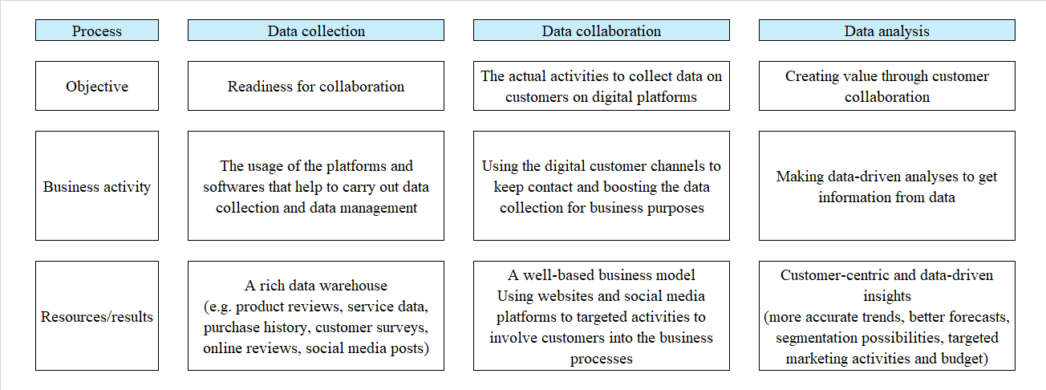
Figure 1. 3D research framework
Source: Authors’ research based on Vial (2019)
Eurostat's 2023 dataset covers all EU member states and serves as our main data source for the empirical analysis. For each of the 27 observations, missing values are marked in the related summary tables below. Businesses are classified into three categories, which are the small, medium, and large categories, based on their number of employees. The unit of measurement is the percentage of enterprises, enabling comparisons of digital adoption levels across firm sizes and countries. The analysis follows the Statistical Classification of Economic Activities in the European Community (NACE Rev.2), encompassing all economic activities except agriculture, forestry, fishing, and mining and quarrying, and excluding the financial sector. The detailed list of indicators applied in this study were gathered in correspondence to the three phases of the research model, namely data collection (Table 1, Data Collaboration (Table 2 and Table 3) and Data Analysis (Table 4).
Table 1. Indicators related to data collection
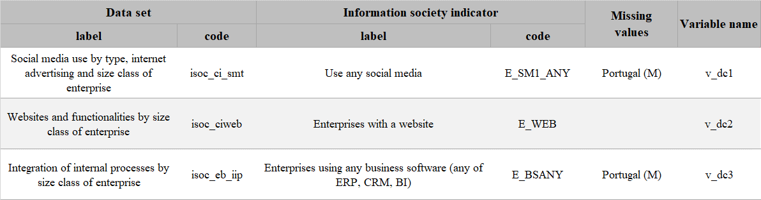
Source: Authors’ research
Table 2. Applied indicators related to collaboration via websites
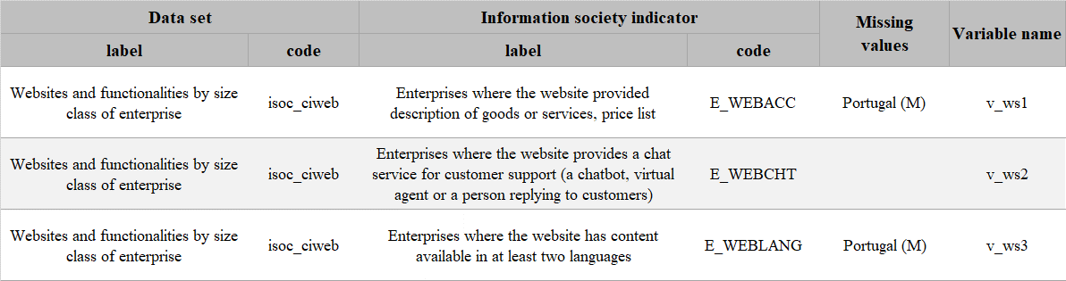
Source: Authors’ research
Table 3. Indicators related to collaboration via social media
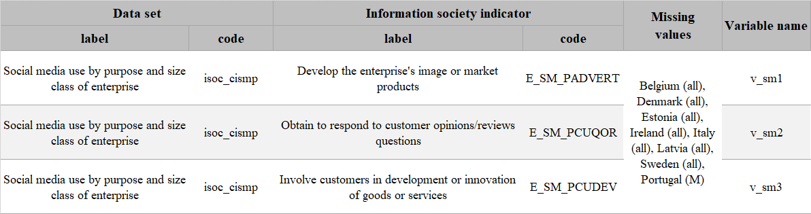
Source: Authors’ research
Table 4. Indicators related to data analysis
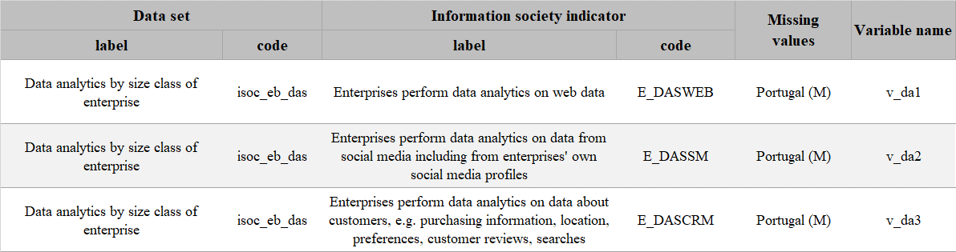
Source: Authors’ research
The authors performed statistical difference analysis across enterprise size categories using the dataset of collected secondary data from the Eurostat database in SPSS (Rahman & Muktadir, 2021). As first step, the dataset was analysed to determine the appropriate methodology for the difference analysis. The data in the applied indicator set contain variables measured on a ratio scale (the percentage of enterprises using different digital tools and services, and the purpose of their use). The determined Alpha-value is p=0.05. The normality values were first calculated using the Shapiro-Wilk test to determine whether parametric or non-parametric tests were appropriate. The results are shown in Table 5.
Table 5. Normality test results
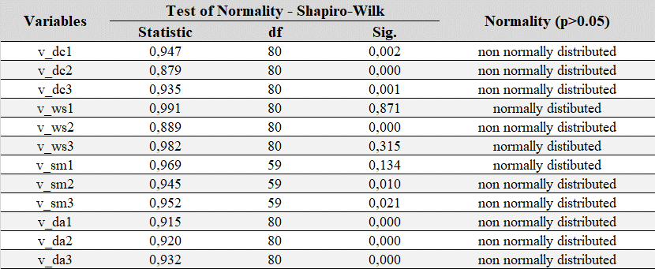
Source: Authors’ research
In those cases where the distribution was normal, the null hypotheses was rejected, so one-way ANOVA test were conducted. When the distribution was not normal, the conditions for carrying out a parametric test were not met. There Kruskal-Wallis one-way ANOVA for k samples tests were performed. In the case of one-way ANOVA tests, we could use the results of the Levene test as the final Test results of Homogeneity of Variances to draw conclusions from.
Furthermore, to better determine whether the differences between the used individual size categories are significant, we used LSD for parametric tests and Pairwise comparisons (Kruskal-Wallis) for non-parametric tests.
RESULTS
In the case of customer collaboration, we defined these organizational capabilities along the dimensions of data collection, data collaboration, and data analysis. Accordingly, we present our results in the following three subchapters based on our proposed 3D framework. Achieving digital transformation requires that enterprises can build databases from appropriate data sources and conduct data analyses aligned with business objectives. Analyses that generate informational value not only within the organisation, but also across firms throughout the entire supply chain are favourable.
In the first part of our analysis, we examined data collection-related metrics. Differences between company size categories in the methods of gathering different kinds of customer data were found to be statistically significant (Table 6) (Kruskal-Wallis test, p < 0.05). Therefore, more tests should be carried out to ascertain the type and degree of the differences between the groups.
Table 6. Results of the Difference Analysis for Data Analytics Variables
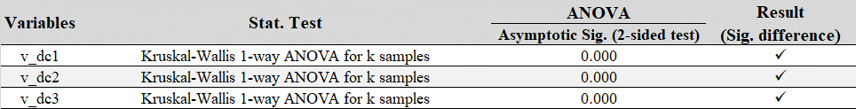
Source: Authors’ research
Table 7. Post hoc Test Results for Data Collection Variables
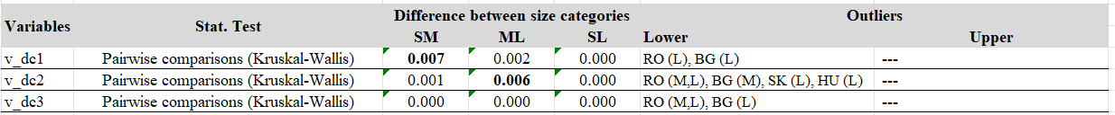
Source: Authors’ research
According to the post hoc tests (Table 7), some group pairs differ significantly. Regarding our first research question (RQ1), in terms of data collection methods using websites, social media platforms, and business software systems, small businesses lag well behind medium-sized and large businesses.
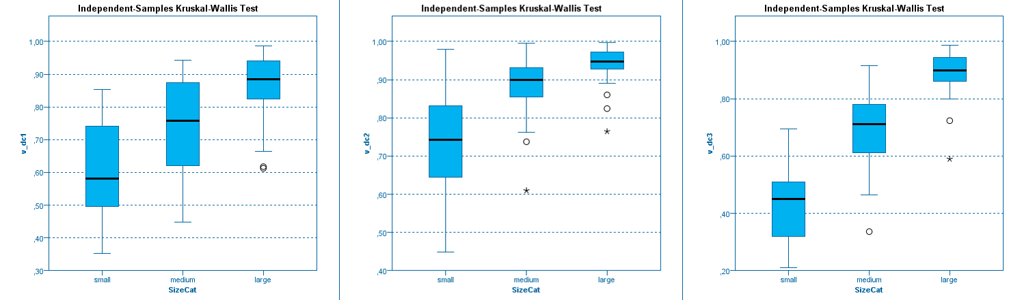 Figure 2. Box-plots on the first test (data collection variables)
Source: Authors’ research
The dispersion for the corresponding indicators within each size category is shown in Figure 2. It emphasises that while medium-sized businesses use web-based data collection more than small businesses, their procedures are still more similar to those of smaller businesses. Even though they haven't yet caught up to big businesses, this points to the beginnings of a digital transformation. Compared to small businesses, medium-sized enterprises exhibit a higher degree of digital maturity and more closely resemble large corporations when it comes to social media data collection. On the other hand, medium-sized businesses once more resemble small businesses when it comes to gathering data using business software, suggesting that digital integration in this sector has not yet been fully realised.
The outliers found among small businesses in web-based data collection might be businesses that are substantially more developed than their peers because of industry-specific factors or outside funding (like EU grants). On the other hand, businesses with less advanced digital practices are indicated by downward outliers in data collection based on business software. Overall, the findings show that medium-sized and especially large enterprises have significantly more sophisticated digital data collection systems. Financial limitations, a lack of digital competencies, and a lack of IT infrastructure are the main obstacles small businesses face in this area.
Results on Customer Collaboration
The robustness of the findings was confirmed by the statistical significance of the ANOVA results (p < 0.05) and the lack of significance of the Levene-test for homogeneity in the customer collaboration area (Table 8).
Table 8. Results of the Difference Tests for Customer Collaboration Variables
Source: Authors’ research
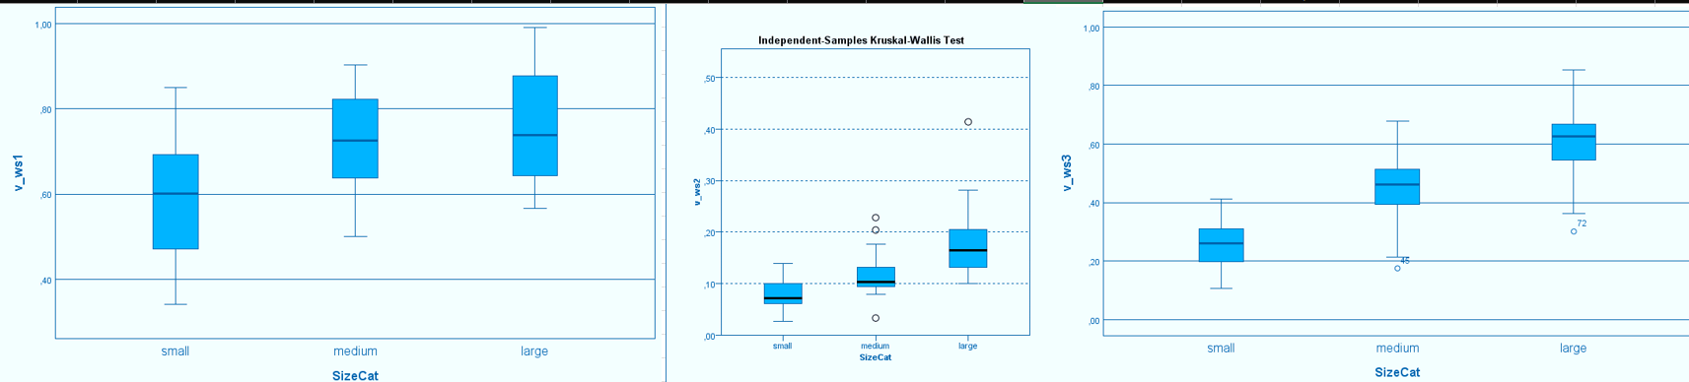
Figure 3. Boxplot on Customer Collaboration related variables
Source: Authors’ research
A boxplot showing the variations among company size categories is shown in Figure 3. The majority of the outliers are found in small businesses, which probably comprise some of the first to use cutting-edge collaboration tools.
Table 9. Post hoc test results on Customer Collaboration
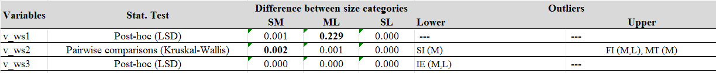
Source: Authors’ research
Statistically significant differences were found in the levels of customer support, multilingual services, and interactive website functions, as indicated by the post hoc tests (Table 9). While medium-sized and large enterprises exhibited similar characteristics regarding basic features (e.g., price lists and service descriptions), customer support practices were more comparable between small and medium-sized firms. This finding underscores that, although basic digital presence is widespread, advanced collaboration features are more characteristic of larger organizations.
Social media data utilisation
The ANOVA analysis revealed statistically significant differences among company size categories regarding the utilisation of social media data (see Table X). The assumption of equal variances is supported by the non-significant results of the Levene test for homogeneity (p > 0.05). The reliability of the results was confirmed by the ANOVA's statistical significance (p < 0.05).
Table 10. One-way ANOVA stat results
Source: Authors’ research
The variations in social media usage among company size categories are depicted in the boxplot in Figure 4. Outliers appear predominantly among small enterprises, suggesting that a few firms exceed the average level within their segment in this area. This could be due to external digital support mechanisms, such as grant funding, consulting programs, or younger leadership, or to industry-specific factors, such as marketing agencies and creative sectors.
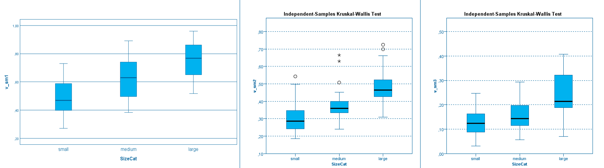
Figure 4. Boxplots on second analysis
Source: Authors’ research
Three main areas showed statistically significant differences between the various company size categories, according to the post hoc tests (Table 11):
1. marketing activities aimed at enhancing brand image,
2. collection of customer feedback, and
3. Customer involvement in product and service development.
Table 11. Post-hoc test results.
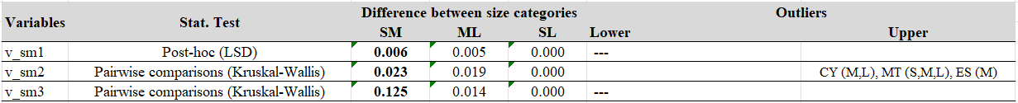
Source: Authors’ research
While there were no statistically significant differences between small and medium-sized businesses, the results generally show that large enterprises use social media much more actively for these purposes. This implies that new, customer-focused strategies have not yet gained traction in these size groups. While active, collaborative, and innovation-oriented use of social media remains comparatively rare, smaller and medium-sized businesses typically use it primarily for basic communication tasks (such as sharing news or maintaining an online presence).
Results on Data Analytics Practices
We found significant differences (p < 0.05) between company size categories based on our statistical analysis of the data analytics indicators (Table 12). This result demonstrates that firm size has a significant impact on data analytics capability.
Table 12. Results of a difference test when data analysis variables are involved
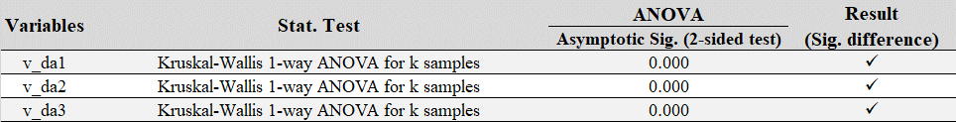
Source: Authors’ research
These variations are depicted in the boxplots in Figure 5, where outlier values indicate the presence of highly competent SMEs that could serve as standards for best practices within their size groups.
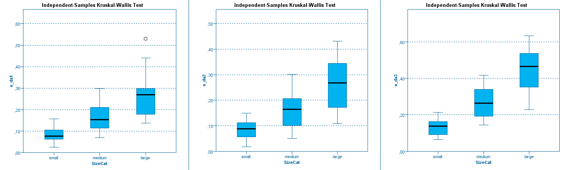
Figure 5. data analysis box plot diagrams
Source: Authors’ research
Analyzing the post hoc test results (Table 13), we can see that the difference between medium and large enterprises is considerably bigger. Here we can find answer to our second research question (RQ2). The results of the pairwise comparison tests here indicate to us that medium-sized firms are slowly, but steadily trying to resolve the technology gap between larger companies and taking up the pace.
Table 13. Data analysis post hoc tests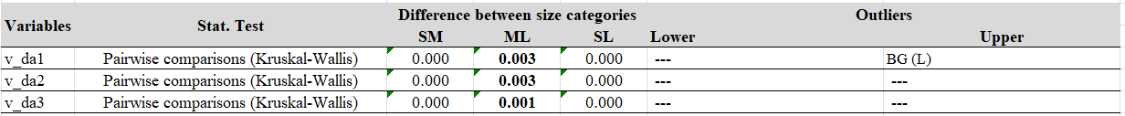
Source: Authors’ research
MANAGERIAL IMPLICATIONS:
Digital transformation in practice concerns people as much as strategy. The main challenge is not the installation of analytical software but the presence of employees who can use these tools in routine tasks. Big data applications rely on techniques such as machine learning and deep learning, which require staff able to interpret results, adjust models, and follow their performance over time. For this reason, ongoing training and internal knowledge sharing become part of everyday organisational work. Smaller companies can often move forward through flexible open-source solutions that support analysis and collaboration without major initial investment. When digital activities are linked to broader business objectives, communication with customers becomes more consistent and managerial decisions rely more on observed information than on intuition, while organisational practices also move closer to wider EU digital policy goals.

CONCLUSIONS:
A finer distinction between firm categories would help tailor IT developments to different levels of readiness and make the transformation process more targeted. The 3D framework indicates that progress in data collection, collaboration, and analysis needs to advance together and remain consistent with broader European Union digital priorities. When this balance is missing, organisations may gather large amounts of data but still struggle to turn them into useful insight. For SMEs, the main limitation is usually not access to information but the ability to use it effectively. Developing employee digital skills therefore becomes central, especially as advanced analytics increasingly depends on AI based approaches such as machine learning and deep learning that require specialised expertise. Open source and low-cost tools can provide realistic starting points even with limited resources, and a clear customer data management roadmap helps integrate digital activities into daily operations, strengthening competitiveness, customer experience, and the quality of managerial decisions.

AUTHOR CONTRIBUTIONS

Conceptualization: Szilvia Botos, Levente P. Bálint.
Data curation: Levente P. Bálint
Formal analysis: Zsófia Nábrádi, Ádám Péntek
Investigation: Ádám Péntek, Zsófia Nábrádi
Methodology: Szilvia Botos, Levente P. Bálint
Project administration: Ádám Péntek, Zsófia Nábrádi
Supervision: Szilvia Botos, Zsófia Nábrádi
Validation: Zsófia Nábrádi, Ádám Péntek
Visualization: Levente P. Bálint
Writing – original draft: Levente P. Bálint
Writing – review & editing: Szilvia Botos, Ádám Péntek, Zsófia Nábrádi

REFERENCES:
- Agazu, B. G., Kero, C. A., & Debela, K. L. (2025). Transformational leadership and firm performance: a systematic literature review. Journal of Innovation and Entrepreneurship, 14, 29. https://doi.org/10.1186/s13731-025-00476-x
- Agnihotri, R., Afshar Bakeshloo, K., & Mani, S. (2023). Social media analytics for business-to-business marketing. Industrial Marketing Management, 115, 110–126. https://doi.org/10.1016/j.indmarman.2023.09.012
- Andrade Navia, J. A., Parra, J. E., & Cedeño, C. C. (2023). Digital market orientation and firm performance: The role of customer and competitor data. Journal of Business Research, 158, 113668. https://doi.org/10.1016/j.jbusres.2023.113668
- Annosi, C.M., Appio, F. P., Brenes, E. R. & Brunetta, F. (2024). Exploring the nexus of digital transformation and sustainability in agribusiness: Advancing a research agenda, Technological Forecasting and Social Change, 206(1), article 123587, ISSN 0040-1625, https://doi.org/10.1016/j.techfore.2024.123587.
- Ardito, L., Filieri, R., Raguseo, E., & Vitari, C. (2024). Artificial intelligence adoption and revenue growth in European SMEs: Synergies with IoT and big data analytics. Internet Research. Advance online publication. https://doi.org/10.1108/INTR-02-2024-0195
- Awamleh, F. T., Albloush, A., Al Jarrah, M., & AlAwamleh, H. K. (2025). The role of data analytics and business intelligence in enhancing the relationship between e-HRM practices and job satisfaction. Problems and Perspectives in Management, 23(2), 208–219. https://doi.org/10.21511/ppm.23(2).2025.14
- Bánhidi, Z., & Dobos, I. (2025). An entropy-based digital maturity index for small and medium enterprises in Hungary. Central European Journal of Operations Research. https://doi.org/10.1007/s10100-025-00985-w
- Bharadwaj, A., El Sawy, O. A., Pavlou, P. A., & Venkatraman, N. (2013). Digital business strategy: Toward a next generation of insights. MIS Quarterly, 37(2), 471–482. https://doi.org/10.25300/MISQ/2013/37:2.3
- Buttle, F., & Maklan, S. (2019). Customer Relationship Management: Concepts and Technologies (Routledge). https://doi.org/10.4324/9781351016551
- Chen, A., Li, L., & Shahid, W. (2024). Digital transformation as the driving force for sustainable business performance: A moderated mediation model of market-driven business model innovation and digital leadership capabilities. Heliyon, 10(8), e29509. https://doi.org/10.1016/j.heliyon.2024.e29509
- Chen, H., Chiang, R. H. L., & Storey, V. C. (2012). Business intelligence and analytics: From big data to big impact. MIS Quarterly, 36(4), 1165–1188. https://doi.org/10.2307/41703503
- Damianos P. Sakas, Dimitrios P. Reklitis, Marina C. Terzi, Costas Vassilakis (2022). Multichannel Digital Marketing Optimisations through Big Data Analytics in the Tourism and Hospitality Industry. Journal of Theoretical and Applied Electronic Commerce Research 2022, 17, 1383-1408. doi: 10.3390/jtaer17040070
- Delen, D., & Demirkan, H. (2013). Data, information and analytics as services. Decision Support Systems, 55(1), 359–363. https://doi.org/10.1016/j.dss.2012.05.044
- Egala, S. B., Amoah, J., Jibril, A. B., Opoku, R., & Bruce, E. (2024). Digital transformation in an emerging economy: Exploring organizational drivers. Cogent Social Sciences, 10(1), 2302217. https://doi.org/10.1080/23311886.2024.2302217
- Eurostat (2025). Database. Available at: https://ec.europa.eu/eurostat/web/main/data/database (accessed: 2025.01.15).
- Földi, K., Vajas, B., & Szakács, A. (2023). Research of Buying Habits of Private Label Goods in the FMCG Market. CONTROLLER INFO, 10(Spec. issue 2), 14–19. DOI: 10.24387/CI.2023.SPECIAL ISSUE 2.3,
- Gillani, F., Chatha, K. A., Jajja, S. S., Cao, D., & Ma, X. (2024). Unpacking digital transformation: Identifying key enablers, transition stages and digital archetypes. Technological Forecasting & Social Change, 203, 123335. https://doi.org/10.1016/j.techfore.2024.123335
- Günther, W. A., Mehrizi, M. H. R., Huysman, M., & Feldberg, F. (2017). Debating big data: A literature review on realising value from big data. The Journal of Strategic Information Systems, 26(3), 191–209. https://doi.org/10.1016/j.jsis.2017.07.003
- Haddara, M., Salazar, A., & Langseth, M. (2023). Exploring the impact of GDPR on big data analytics operations in the e-commerce industry. Procedia Computer Science, 219, 767–777. https://doi.org/10.1016/j.procs.2023.01.350
- Hadiyati, E., Mulyono, S., & Gunadi. (2024). Digital marketing as a determinant variable for improving the business performance. Innovative Marketing, 20(3), 28-41. https://doi.org/10.21511/im.20(3).2024.03
- Han, F., Wang, M., & Wu, Z. (2025). Information sharing and channel structure in e-commerce supply chain considering data-driven marketing. PLoS One, 20(9), e0328040. https://doi.org/10.1371/journal.pone.0328040
- Hernández-Ortega, B. I., Stanko, M. A., Rishika, R., Molina-Castillo, F.-J., & Franco, J. (2022). Brand-generated social media content and its differential impact on loyalty program members. Journal of the Academy of Marketing Science, 50(5), 1071–1090. https://doi.org/10.1007/s11747-022-00869-4
- Hjelle, S., Mikalef, P., Altwaijry, N., & Parida, V. (2024). Organizational decision making and analytics: An experimental study on dashboard visualizations. Information & Management, 61, 104011. https://doi.org/10.1016/j.im.2024.104011
- Hortovanyi, L., Morgan, R. E., Vuksanovic Herceg, I., Djuricin, D., Hanak, R., Horvath, D., Mocan, M. L., Romanova, A., & Szabo, R. Z. (2023). Assessment of digital maturity: The role of resources and capabilities in digital transformation in B2B firms. International Journal of Production Research, 61(23), 8043–8061. https://doi.org/10.1080/00207543.2022.2164087
- Itani, O. S., Agnihotri, R., & Dingus, R. (2017). Social media use in B2B sales and its impact on competitive intelligence collection and adaptive selling: Examining the role of learning orientation as an enabler. Industrial Marketing Management, 66, 64–79. https://doi.org/10.1016/j.indmarman.2017.06.012
- Jeza S., & Lekhanya, M. L. (2022). The influence of digital transformation on the growth of small and medium enterprises in South Africa. Problems and Perspectives in Management, 20(3), 297-309. doi:10.21511/ppm.20(3).2022.24
- Justy, T., Pellgrin-Boucher, E., Lescop, D., Granata, J., & Gupta, S. (2023). On the edge of Big Data: Drivers and barriers to data analytics adoption in SMEs. Technovation, 127, 102850. https://doi.org/10.1016/j.technovation.2023.102850
- Kothapalli, K. R. V. (2022). Exploring the impact of digital transformation on business operations and customer experience. Global Disclosure of Economics and Business, 11(2), 103–114. DOI: 10.18034/gdeb.v11i2.760
- Lemon, K. N., & Verhoef, P. C. (2016). Understanding customer experience throughout the customer journey. Journal of Marketing, 80(6), 69–96. https://doi.org/10.1509/jm.15.0420
- Limpeeticharoenchot, S., Cooharojananone, N., Chavarnakul, T., Charoenruk, N., & Atchariyachanvanich, K. (2022). Adaptive big data maturity model using latent class analysis for small and medium businesses in Thailand. Expert Systems with Applications, 206, 117965. https://doi.org/10.1016/j.eswa.2022.117965
- Macredie, R. D., & Mijinyawa, K. (2011). A theory-grounded framework of Open Source Software adoption in SMEs. European Journal of Information Systems, 20(2), 237–250. https://doi.org/10.1057/ejis.2010.60
- Marino-Romero, J. A., Palos-Sánchez, P. R., Velicia-Martín, F. A., & Rodrigues, R. G. (2022). A study of the factors which influence digital transformation in Kibs companies. Frontiers in Psychology, 13, 993972. https://doi.org/10.3389/fpsyg.2022.993972
- Marolt, M., Lenart, G., Zimmermann, H.-D., & Pucihar, A. (2022). Social media use and business performance in SMEs. Sustainability, 14(22), 15029. https://doi.org/10.3390/su142215029
- Maroufkhani, P., Tseng, M.-L., Iranmanesh, M., Ismail, W. K. W., & Khalid, H. (2020). Big data analytics adoption: Determinants and performances among small to medium-sized enterprises. International Journal of Information Management, 54, 102190. https://doi.org/10.1016/j.ijinfomgt.2020.102190
- Matt, C., Hess, T., & Benlian, A. (2015). Digital transformation strategies. Business & Information Systems Engineering, 57(5), 339–343. https://doi.org/10.1007/s12599-015-0401-5
- Mikalef, P., Boura, M., Lekakos, G., & Krogstie, J. (2019). Big data analytics and firm performance: Findings from a mixed-method approach. Journal of Business Research, 98, 261–276. https://doi.org/10.1016/j.jbusres.2019.01.044
- Mikalef, P., Krogstie, J., Pappas, I. O., & Pavlou, P. (2020). Investigating the effects of big data analytics capabilities on firm performance: The mediating role of dynamic capabilities. Information & Management, 57(2), 103169. https://doi.org/10.1016/j.im.2019.103169
- Morabito, V. (2015). Big Data and Analytics: Strategic and Organizational Impacts. Cham: Springer International Publishing. https://doi.org/10.1007/978-3-319-10665-6
- Munandar, J. M., Cahyadi, A., & Andrianto, R. (2025). Digital marketing orientation and performance of sustainable tourism SMEs: The mediating role of customer orientation. Sustainability, 17(3), 1125. https://doi.org/10.3390/su17031125
- Payne, A., & Frow, P. (2005). A Strategic Framework for Customer Relationship Management. Journal of Marketing, 69(4), 167–176. https://doi.org/10.1509/jmkg.2005.69.4.16
- Payne, E. M., Peltier, J. W., & Barger, V. A. (2017). Omni-channel marketing, integrated marketing communications and consumer engagement: A research agenda. Journal of Research in Interactive Marketing, 11(2), 185–197. https://doi.org/10.1108/JRIM-08-2016-0091
- Peretz-Andersson, E., Tabares, S., Mikalef, P., & Parida, V. (2024). Artificial intelligence implementation in manufacturing SMEs: A resource orchestration approach. International Journal of Information Management, 77, 102781. https://doi.org/10.1016/j.ijinfomgt.2024.102781
- Petropoulou, A., Angelaki, E., Rompogiannakis, I., Passas, I., Garefalakis, A., & Thanasas, G. (2024). Digital Transformation in SMEs: Pre- and Post-COVID-19 Era: A Comparative Bibliometric Analysis. Sustainability, 16(23), 10536. https://doi.org/10.3390/su162310536
- Phanitrat, K., Puriwat, W., & Hoonsopon, D. (2025). Analyzing factors influencing SME readiness for smart retail: A structural equation model approach. Problems and Perspectives in Management, 23(1), 132-145. https://doi.org/10.21511/ppm.23(1).2025.10
- Puklavec, B., Oliveira, T., & Popovič, A. (2018). Understanding the determinants of business intelligence system adoption stages: An empirical study of SMEs. Industrial Management & Data Systems, 118(1), 236–261. https://doi.org/10.1108/IMDS-05-2017-0170
- Ragazou, K., Passas, I., Garefalakis, A., & Zopounidis, C. (2023). Business intelligence model empowering SMEs to make better decisions and enhance their competitive advantage. Discover Analytics, 1, Article 2. https://doi.org/10.1007/s44257-022-00002-3
- Sakas, D. P., Reklitis, D. P., & Terzi, M. C. (2023). Leading logistics firms’ re-engineering through the optimization of the customer’s social media and website activity. Electronics, 12(11), 2443. https://doi.org/10.3390/electronics12112443
- Sakas, D. P., Reklitis, D. P., Terzi, M. C., & Vassilakis, C. (2022). Multichannel digital marketing optimizations through big data analytics in the tourism and hospitality industry. Journal of Theoretical and Applied Electronic Commerce Research, 17(4), 1383–1408. https://doi.org/10.3390/jtaer17040070
- Sánchez, E., Calderón, R., & Herrera, F. (2025). Artificial Intelligence Adoption in SMEs: Survey Based on TOE–DOI Framework, Primary Methodology and Challenges. Applied Sciences, 15(12), 6465. https://doi.org/10.3390/app15126465
- Senna, P. P., Ferreira, L. M. D. F., Barros, A. C., Bonnín Roca, J., & Magalhães, V. (2023). Development of a digital maturity model for Industry 4.0: An empirical validation using the Technology-Organization-Environment framework. Technological Forecasting and Social Change, 192, 122546. https://doi.org/10.1016/j.techfore.2023.122546
- Seppänen, M., Ukko, J., & Saunila, M. (2025). Understanding determinants of digital transformation and digitizing management functions in incumbent SMEs. Digital Business, 100106. https://doi.org/10.1016/j.digbus.2025.100106
- Sivarajah, U., Kamal, M. M., Irani, Z., & Weerakkody, V. (2017). Critical analysis of big data challenges and analytical methods. Journal of Business Research, 70, 263–286. https://doi.org/10.1016/j.jbusres.2016.08.001
- Slávik, Š., & Bednárová, V. (2024). Factors and circumstances affecting the business performance of firms based on new technologies. Problems and Perspectives in Management, 22(3), 458–474. https://doi.org/10.21511/ppm.22(3).2024.35
- Soroka, A., Liu, Y., Han, L., & Haleem, M. S. (2017). Big Data Driven Customer Insights for SMEs in Redistributed Manufacturing. Procedia CIRP, 63, 692-697. https://doi.org/10.1016/j.procir.2017.03.319
- Sundström, M., Alm, K. H., Larsson, N., & Dahlin, O. (2021). B2B social media content: engagement on LinkedIn. Journal of Business & Industrial Marketing, 36(3), 454-468. https://doi.org/10.1108/JBIM-02-2020-0078
- Sütő, D., Bajnai, P., & Fenyves, V. (2024). Forecasting the financial performance of small and medium-sized enterprises: Evidence from the Hungarian food retail sector. Ukrainian Food Journal, 13(4), 794–808. https://doi.org/10.24263/2304-974X-2024-13-4-12
- Sytnik, N., & Kravchenko, M. (2021). Application of knowledge management tools: Comparative analysis of small, medium, and large enterprises. Journal of Entrepreneurship, Management and Innovation, 17(4), 121–156. https://doi.org/10.7341/20211745
- Tan, F., Zhang, O., Mehrotra, A, Attri, R & Tiwari, H. (2023). Unlocking venture growth: Synergizing big data analytics, artificial intelligence, new product development practices, and inter-organizational digital capability. Technological Forecasting and Social Change. 200 (1), article 123174, ISSN 0040-1625, https://doi.org/10.1016/j.techfore.2023.123174.
- Truant, E., Broccardo, L., & Dana, L-P. (2021). Digitalisation boosts company performance: an overview of Italian listed companies. Technological Forecasting and Social Change, 173(1), article 121173, ISSN 0040-1625, https://doi.org/10.1016/j.techfore.2021.121173.
- Varga, D., & Kiss, V. (2023). A Domestic Investigation of Online Banking. International Journal of Engineering and Management Sciences, 8(1), 22–32. https://doi.org/10.21791/IJEMS.2023.1.4
- Vasquez-Reyes, B. J., & Cordova-Buiza, F. (2024). Inbound social media marketing and increased sales in SMEs: A correlational study in the pet food industry. Innovative Marketing, 20(3), 132-143. https://doi.org/10.21511/im.20(3).2024.11
- Vial, G. (2019). Understanding digital transformation: A review and a research agenda. The Journal of Strategic Information Systems. 28(2), pp. 118-144. ISSN 0963-8687. https://doi.org/10.1016/j.jsis.2019.01.003.
- Wong, A. P. H., & Kee, D. M. H. (2022). Driving Factors of Industry 4.0 Readiness among Manufacturing SMEs in Malaysia. Information, 13(12), 552. https://doi.org/10.3390/info13120552
- Wu, C.-W., Botella-Carrubi, D., & Blanco-González-Tejero, C. (2024). The empirical study of digital marketing strategy and performance in SMEs. Technological Forecasting & Social Change, 200, 123142. https://doi.org/10.1016/j.techfore.2023.123142
- Wu, T., Peng, C.-H., Sia, C. L., & Lu, Y. (2024). Website localization strategies to promote global e-commerce: The moderating role of individualism and collectivism. MIS Quarterly, 48(1), 31–66. https://doi.org/10.25300/MISQ/2022/15542

